1. What is SDLC?
2. Software development life cycle is a structure imposed on the development of a software product that defines the process for planning , implementation , testing ,documentation , deployment and ongoing maintenance and support .
3. What is software testing?
4. Software testing is a process used to identify the correctness, completeness and quality of developed computer software.
5. What is agile methodology?
6. Agile SDLC model is a combination of iterative and incremental process models with focus on process adaptability and customer satisfaction by rapid delivery of working software product.
7. What is SRS?
8. A software requirement specification is complete description the behaviour of the system to be developed.
9. What is oops?
10. Oops is object oriented programming system black box testing.
11. Write basic concepts of oops?
12. Oops object oriented programming systems : black box testing
13. Class: is an collection of data member (variable) and member function (process),(methods)with its behaviours.
14. Objects: its an instances of an class
15. Encapsulation : data hiding : wrapping up of into single unit private your data member and member function data
16. Inheritance: properties of parent class extends into child class
17. Polymorphism : ability to take one name having many forms or multiple forms
18. Abstraction : data hiding :only esensial part should be display rest of the part will be hide.
19. What is object?
20. Its an instances of an class

1. What is class?
2. Is an collection of data member (variable) and member function (process),(methods)with its behaviours.

1. What is Encapsulation?
2. Data hiding , wrapping up of into single unit private your data member and member function data
3. What is inheritance?
4. Properties of parent class extends into child class. Properties of super class extends into subclass.
5. What is Polymorphism?
6. Ability to take one name having many forms or multiple forms.

12.Draw usecase on online book shopping

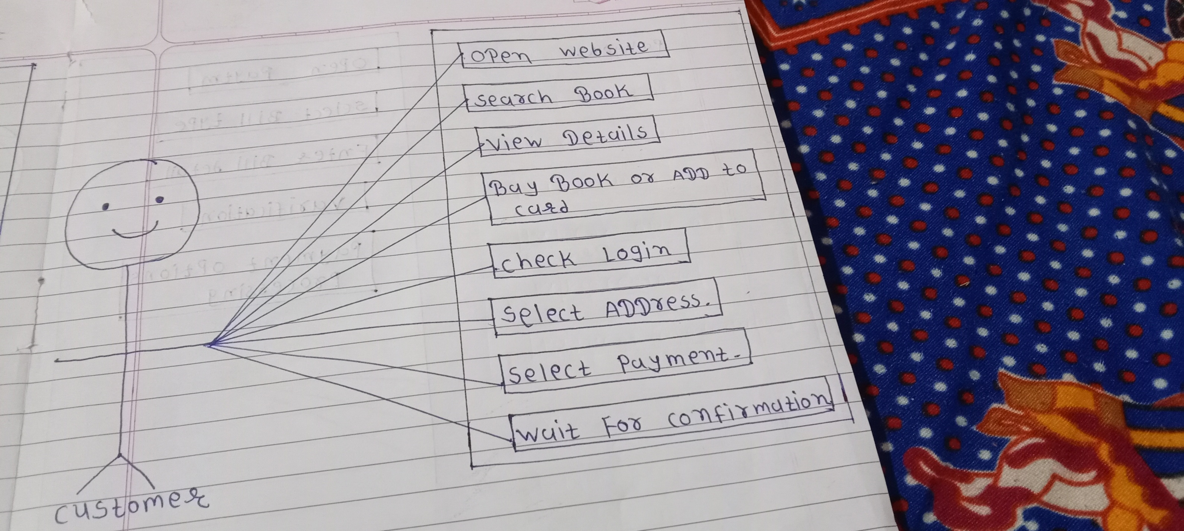

1. Draw usecase on online bill payment system

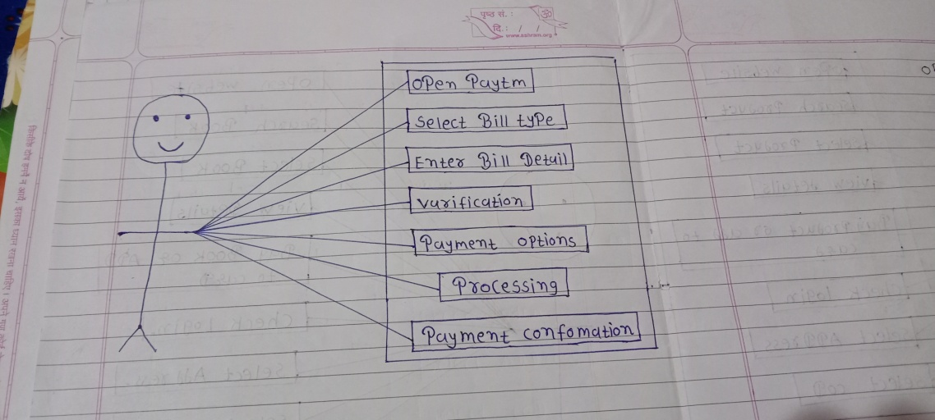

14. write SDLC phase with basic introduction?

1. Software development life cycle is a structure imposed on the development of a software product that defines the process for planning , implementation , testing documentation , deployment and ongoing maintenance and support .
2. Requirements Gathering

* Three type of problems can arise
* Lack Of Clarity : It hard to write document that both precise and easy-to-read.
* Requirement Confusion: functional and non-functional requirement tend to be intertwined.
* Requirement Amalgamation: several different requirement may be expressed together.

1. Analysis Phase

* The analysis phase defines the requirement of the system independent of how these requirement will be accomplished.
* The deliverable result at the end of this phase is a requirement document
* Ideally, this document states in a clear and precise fashion what is to be built.

1. Design phase

* Design architecture document
* Implementation plan
* Critical priority analysis

1. Implementation phase

* Implementation-code
* Critical error remove
* The Implementation phase deals with issue of quality, performance, baseline ,libraries and debugging.

1. Testing phase

* The developing organization or team will have some mechanism to document and tack defects and deficiencies.
* Configuration and version management
* Reengineering

1. Maintenance

* Corrective maintenance : identify and repairing defects
* Adaptive maintenance : adapting the existing solution to the new platforms.
* Perfective maintenance: implementing the new on decides the utility and value of the software at a particular level of quality outweighs the impact of the known defects and deficiencies.

15. Explain phase of the waterfall model?

A. The classical software life cycle n the software development as a step by step “waterfall” between the various development phases.

* Requirement must be frozen” to early in the life product.
* The project is short.

\*pros

* Simple and easy to understand and use
* Clearly defined the stages.
* Well understood milestones.
* Easy to arrange tasks.
* Process and results are well documented.

\*Cons

* High amounts of risk and uncertainty
* Not a good model for complex and object-oriented projects.
* Poor model for long and ongoing projects.
* Not suitable for the projects where requirements are at a moderate to high risk of changing.

16. Write phase of spiral model?

A. Spiral model is very widely used in the software industry as it is in synch with the natural development process of any product learning with maturity and also involves minimum risk for the customer as well as the development firms.

* For medium to high-risk projects.
* Long term project

\*Pros

* Changing requirements can be accommodated.
* Allows for extensive use of prototypes.
* Requirements can captured more accurately.
* Users see the system early.
* Development can be divided into smaller parts and more risky parts can be developed earlier which helps better risk management.

\*cons

* Managements is more complex
* End of project may not be known early
* Not suitable for small or low risk projects and could be expensive for small projects.
* Process is complex
* Spiral may go indefinitely.
* Large number of intermediate stages requires excessive documentation.

17. Write agile manifesto principles?

A. Agile SDLC model is a combination of iterative and incremental process models is with focus on process adaptability and customer satisfaction by rapid delivery of working software product.

\* Agile methods break the product into small incremental builds.

\* These builds are provided in iterations.

\*Each iteration typically lasts from about one to three weeks.

\* What is agile?

* Agile model believes that every project needs to be handled differently and the existing methods need to be tailored to best suit the project requirements. in agile the task are divided to time boxes to deliver specific features for a release.
* Agile thought process had started early in the software development and started becoming popular with time due to its flexibility and adaptability.

18. Explain working methodology of agile and also write pros and cons.

A.\*Pros

* It a very realistic approach to software development
* Promotes teamwork and cross training?
* Functionality can be developed rapidly and demonstrated.
* Suitable for fixed and changing requirements.
* Delivers early partial working solutions

\*cons

* Not suitable for handling complex dependencies.
* More risk of sustainability , maintainability and extensibility.
* Depends heavily on customer interaction , so if customer is not clear , team can be driven in the wrong direction.
* There is very high individual dependency, since there is minimum documentation generated.

19. Draw usecase on online shopping product using COD.

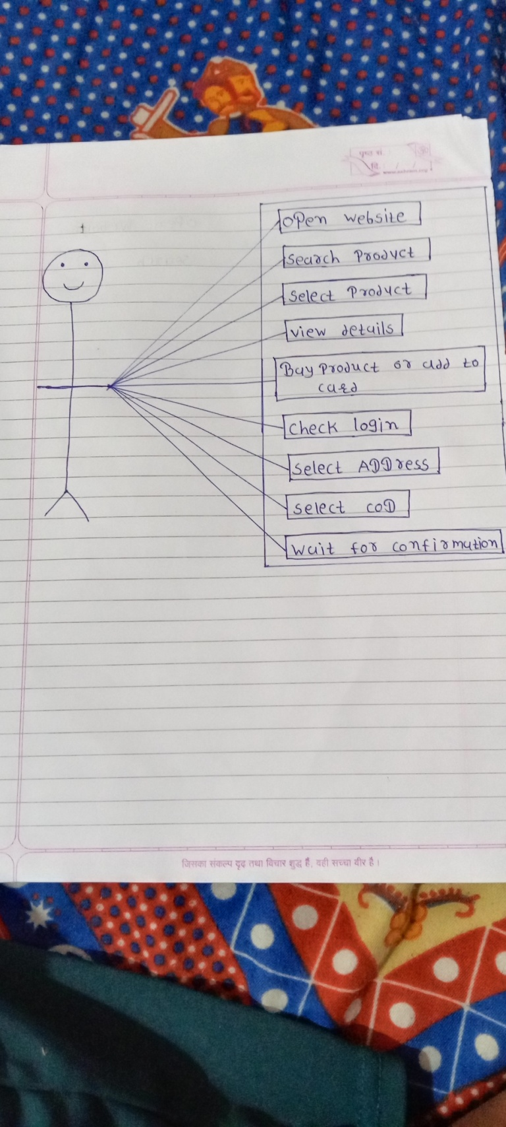

20. Draw usecase on online shopping product using payment gateway.

